**CA2020 Software Developer Bootcamp**

Farhana Akter

Virginia, USA



**Assignment 2**

**19 May, 2020**

* **Practice on the following commands:**
  + LISTING

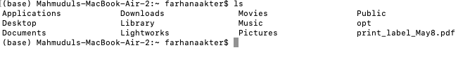

* + DIRECTORY



* + FILE



* + MOVE

**mv [OPTIONS] SOURCE... DESTINATION**

* + RENAME

**rename [OPTIONS] perlexpr files**

* + COPY

**cp [OPTIONS] SOURCE... DESTINATION**

* + MAN



* + WHOAMI



* + WHO



* + NETWORKING (ping, hostname, ifconfig, netstat etc)

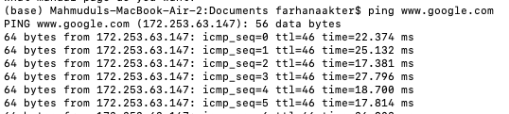

$ ping [www.google.com](http://www.google.com)

$ ping 172.217.13.28

$ netstat -e

$ ipconfig getifaddr en0

$ hostname

**TASK: 01**

**Create directories which would have the following structure by using only mkdir command:**

**HIERARCHY:**

consultadd/

|-- Python

| `-- Django

| `-- restframework

|-- java

| `-- springboot

|-- javascript

| `-- angular

| `-- react

|-- SQL

| `-- mysql

`-- bootcamp

**HINT :** Use mkdir command in single line

* + - $ mkdir -p consultadd/{Python/Django,restframework,java,springboot,javascript,angular},react/SQL/mysql/bootcamp}



**TASK 02:**

* Create Directory called consultadd

mkdir path/consultadd

* Inside that create 5 more directories named them as dir1, dir2, dir3, dir4 and dir5

mkdir dir1 dir2 dir3 dir4 dir5

* What would be the output of Long Listing after creating these directories?

$ ls -l

* List all the directories with ls and echo * and see the difference.
* Create a 2 files named them file1.txt and file2.txt inside dir3
* Move dir5 into the dir3

$ mv dir5 dir3

* Remove dir 3 after moving all files from dir3 to dir2.

$ rm -r dirname

* Go to the dir2 and create one more file with name index.html
* Move to top level directory
* Check the permission of all files and directory from current place make sure when you do **pwd** it should be on consultadd

**(- rw- rw- r--)**

* Rename all files of dir2 with extension of .txt to .py

**HINT:** Use Rename command - Make sure you install it first.

$ rename 's/.txt/.py/' *.txt

**TASK: 03**

* **What is Nano Editor?**

Nano is a modeless editor so we can start typing immediately to insert text.

* + **How to create a sample file in Nano Editor?**

We need to log into the server to create a sample file. Then, we’ll navigate to the directory location we want to create the file, or edit an existing file. We’ll type in nano followed by the name of the file.

For example,  
*A new file opens named index.html:  
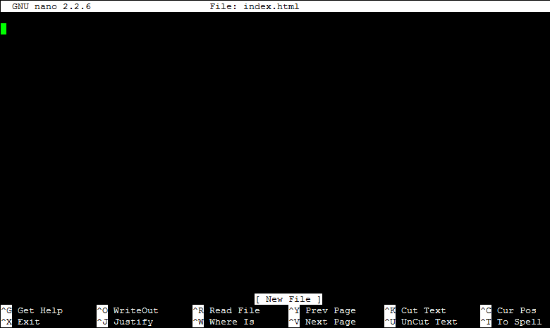*

(Source: DreamHost Knowledge Base)

We’ll start typing our data into the file. When we're ready to save the file, hold down the Ctrl key and press the letter 'O' (Ctrl + O). *T*he bottom of the prompt will ask us to confirm the name of the file, which is already set as 'index.html':  
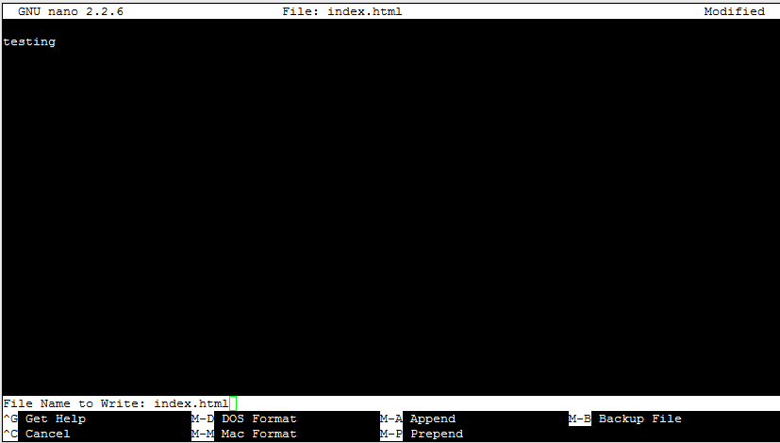

Then we’ll click the 'Enter' key on our keyboard to save. When finished, click Ctrl + X to close 'nano' and return to our shell.

* + **How to save files?**

Ctrl + X will quit the editor and you will be asked if you want to save your changes. If you do, press Y for Yes.

* **What is a Vi Editor?**

The vi editor is a fast and powerful screen editor which is available on almost all Unix systems. Vi can be used from any type of terminal.

* + **Operation in Vi Editor**

Vi editor has two modes of operation: 1) Command mode commands which cause action to be taken on the file, and 2) Insert mode in which entered text is inserted into the file.

**TASK: 04**

* Type **finger** to see your account and name.

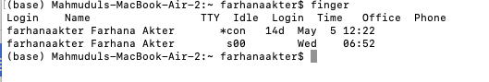

* Type **cal** to see this month’s calendar.

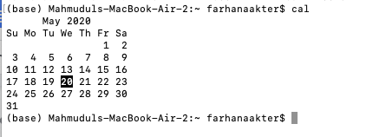

* Create a file and give a name random.txt to it with content into it which says “Hello Welcome to the Consultadd Inc Bootcamp”.
* Display the same content using **cat** command.



**TASK: 05**

* **Explain the workflow of the Internet in one paragraph.**

The Internet is as much a collection of rules for how computers and programs should behave as it is a physical network of computers. The Internet is made up of routers. The Internet works through a packet routing network in accordance with the Internet Protocol (IP), the Transport Control Protocol (TCP) and other protocols. Each router's job is to know how to move packets along from their source to their destination. A packet will have moved through multiple routers during its journey.

* **How LAN is different from the WAN network?**

LANs typically operate within the same building or the same floor of an office building. One of the major advantages of LANs is the speed they can offer. A WAN is an interconnected network of LANs. A WAN differs from a LAN because it is not restricted by geographic location. If we need to reach a wider area, we’ll need to look at implementing a WAN.